4 types of body tissues:

List the ways cells can be held together in tissues (discussed in class):

Epithelial tissue

Characteristics:

2 names (1st and 2nd)

Epithelial tissue | Picture | Function | Notes
Simple Squamous Epithelium
Simple cuboidal epithelium
Nonciliated Simple Columnar Epithelium
Ciliated Simple Columnar Epithelium
Nonciliated Pseudostratified Columnar Epithelium
Ciliated Pseudostratified Columnar Epithelium

Stratified epithelial tissue | Picture | Function | Notes
Stratified squamous epithelium
Stratified cuboidal epithelium
Stratified columnar epithelium

Transitional Epithelium | Picture | Function | Notes
Transitional epithelium

Glandular epithelium is classified by:

Endocrine
Picture | Function | Notes

Exocrine
Picture | Function | Notes

Cells of the Connective tissue:
Cell type | Function/Characteristics

Key functions of connective tissue:

4 Classes of connective tissue:
Tissue class/example | Image | Subclasses | Cells | General Features
Connective Tissue Proper

Cartilage

Bone

Blood

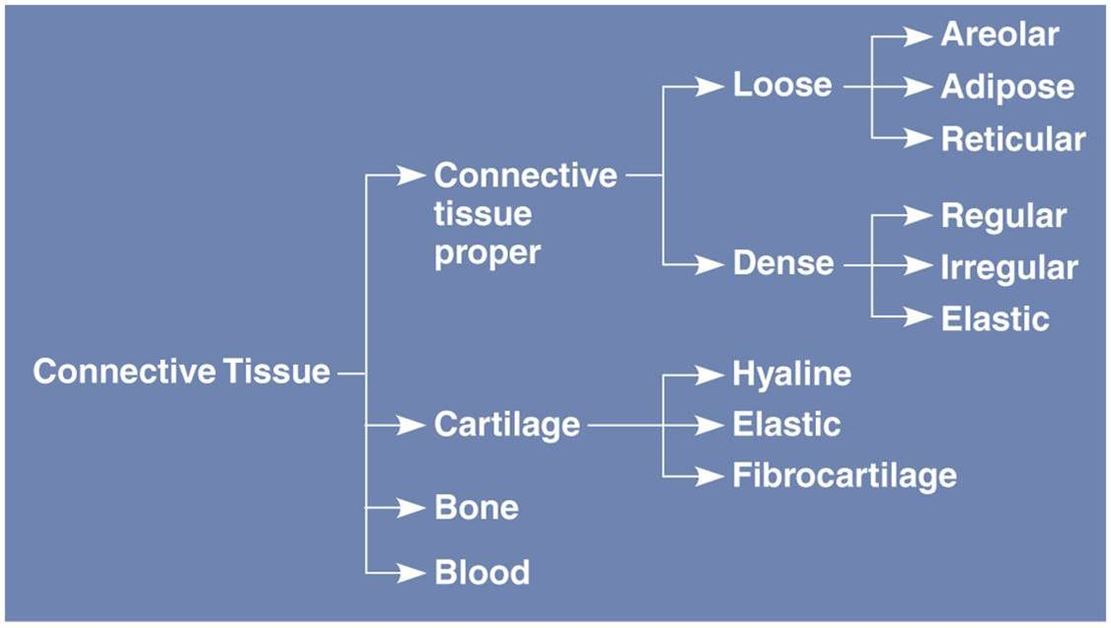
Extracellular matrix:
Characteristics:

Composed of: | Components | Function(s)
Fibers
Ground substance

Muscle Tissue
Tissue type | Image | Voluntary/Involuntary | Characteristics

Nervous Tissue:
Kinds of Cells | Function | Location

2 Types of Body Membranes:
Epithelial membranes
Examples | Description/location/function
Mucous
Serous
cutaneous

Synovial membranes:
Where found | Description

Tissue repair:

